Likes & Dislikes + Personality

- Name 5-10 activities you like a lot. Write one sentence next to each to explain why you feel this way.

- Name 5-10 activities you dislike a lot. Write one sentence next to each to explain why you feel this way.

Watch the WatchWellCast Video Intro to the Myers-Briggs Personality Test to learn a bit about the test you will take. https://www.youtube.com/watch?v=nHSZ3_VMgjU
Take a free (and shorter) version of the personality test to see what personality you have according to the test.
https://www.16personalities.com/free-personality-test
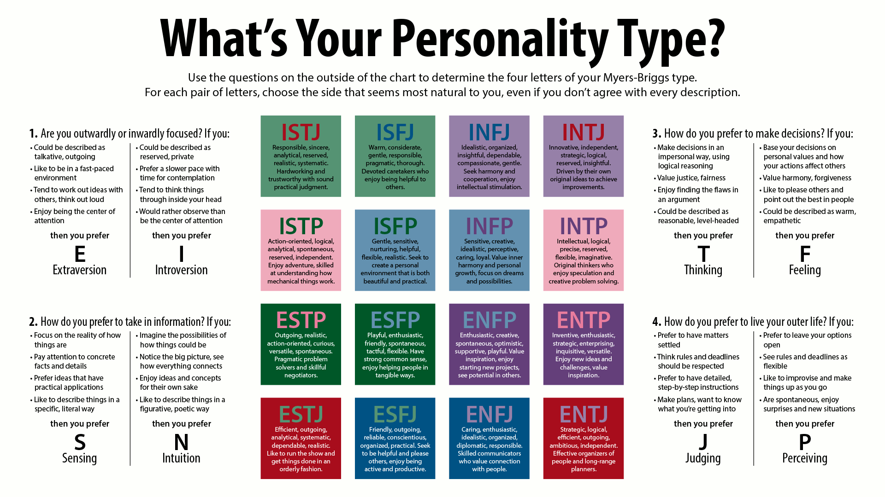
CC BY-SA 3.0 File:MyersBriggsTypes.png Created: 28 January 2014

- What was your result?

- Do you agree with results why or why not?

- Which characteristics surprised you?

- Which characteristics applied to your likes or dislikes? Explain how.

- How might you apply these ideas to your future?

